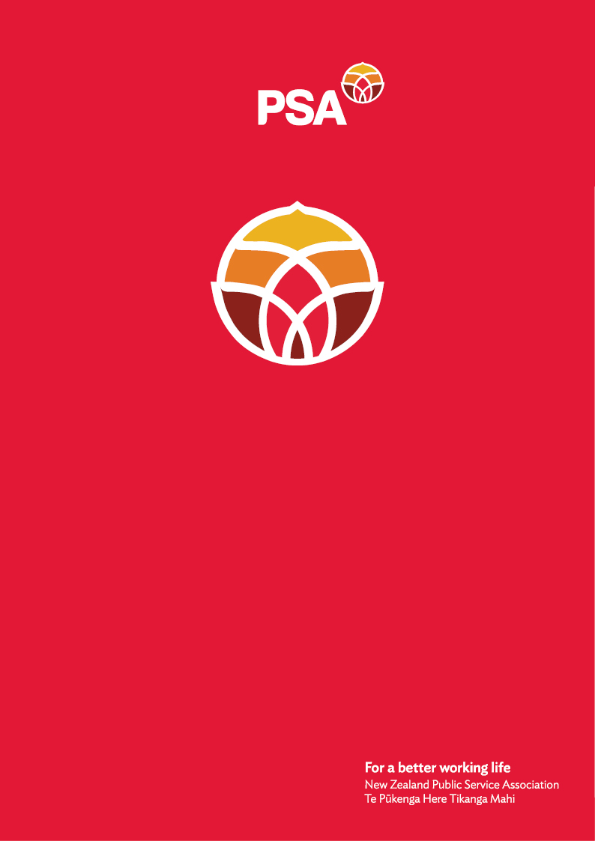
PSA submission to the Social Services and Community Select Committee

Disability Support Services Bill

June 2026
PSA submission to the Social Services and Community Select Committee on the Disability Support Services Bill

June 2026
About the PSA
- The New Zealand Public Service Association Te Pūkenga Here Tikanga Mahi (the PSA) is the largest trade union in Aotearoa New Zealand with over 98,000 members. We are a democratic organisation, representing members in the public service, the wider state sector, state owned enterprises, local government, tertiary education institutions and non-governmental organisations working in the health, social services, and community sectors.
- The PSA represents more than 10,000 workers in the Community Public Service sector including care and support workers working in home and community support services (HCSS), mental health and addiction and disability support, including family carers. We have a strong history of advocating for and achieving fair terms and conditions of employment for these workers.
- The PSA is an affiliate of the New Zealand Council of Trade Unions Te Kauae Kaimahi (CTU), Public Services International (PSI) and UniGlobal.
Summary of PSA response to the Bill
- We strongly oppose this bill and submit that it:
- Undermines and limits the Supreme Court ruling recognising family carers as employees.
- Removes or limits basic employment rights and protections.
- Leaves important substantive and operational detail to secondary legislation
- Reinforces systemic inequality and discrimination against family carers.
- Disregards the human rights of and infantilises adult disabled people and entrenches administrative disadvantage.
- Has been developed without adequate consultation with affected communities.
- Creates long-term risks for the sustainability and quality of disability support services.
- We strongly urge members of the Committee to report back to the House that it should not proceed.
Our concerns
The Bill undermines and limits a Supreme Court decision
- In December, the Supreme Court ruled that two parents, Christine Fleming and Peter Humphreys, providing full-time care to their disabled children are employees of the government, entitled to the same protections as other workers. The Court recognised the real work that family carers do.
- Rather than applying this ruling to other family carers in similar circumstances in good faith, the Bill is designed to circumvent and limit its effect. The Government has taken this landmark Supreme Court win for family carers and is using this Bill to write it out of law.
- This represents a serious constitutional concern. It signals that when courts affirm workers’ rights, those rights can simply be legislated away. This undermines the confidence of New Zealanders in both the rule of law and the employment relations framework and is highly undesirable. It is the Government using its power directly against some of New Zealand’s most vulnerable individuals and families and would be bad law.
- We are also concerned at the retrospective effect of this Bill which provides that the family carers that have initiated employment proceedings since the Supreme Court decision will have their cases extinguished.
- We share the view of the New Zealand Law Society whose June 2025 report Strengthening the Rule of Law in Aotearoa New Zealand recommends that where legislation is intended to override a decision of the courts, or to apply retrospectively, the scale, nature and reason for such a change should be given careful consideration, and these deliberations should be set out in the information provided to the public for their consideration during consultation.
- This is not the case here. The Regulatory Impact Statement that accompanies the Bill admits under the heading “Limits and Constraints on Analysis” that “due to the urgency and the confidential nature of the proposed legislative options that take a precautionary approach to the judgment, there has not been any community or prior agency consultation on the specific legislative proposals.”
- The Bill is also being progressed through Parliament within a very short timeframe, with submissions closing 12 June 2026. This exacerbates our concern as this limits the opportunity for disabled people, whānau, carers, providers, and representative organisations to properly consider and respond to the proposed changes at the select committee stage.
The Bill denies employment rights to a large number of workers
- People caring for disabled people perform highly skilled, demanding work that is essential to the wellbeing of those they care for.
- “The care I provide for my daughter is not only an act of love, [it] goes beyond love alone. It involves dedication, knowledge and responsibility that meets the same standards expected in professional care settings,” says PSA member Peter Humphreys.
- However, by deeming them not to be employees, this Bill strips employment rights, including access to New Zealand’s minimum code from any worker providing DSS-funded support services to another person unless a written employment agreement is in place. The result is that these workers will not receive:
- The minimum wage
- Sick leave
- Holidays
- Rest breaks
- Kiwisaver
- Equal pay
- Access to collective bargaining and representation; or
- Access to workplace dispute resolution processes.
- This is achieved by way of clauses 12, 13 and 14 of the Bill. The PSA strongly opposes clauses 13 and 14 and notes that they risk a far wider impact than just family carers.
- Even where a written employment agreement does exist, the Bill is at pains to distance the Crown or a contracted provider from any employment obligations. Clause 15 provides that, for the purposes of the Employment Relations Act 2000, they cannot be a “controlling third party” in relation to an employee who provides DSS-funded disability support services.
- This limitation on the employment rights of workers who are accepted to be employees is unnecessary and harsh. Further, the effect of this is that this provision goes beyond exempting the Crown and contracted providers from liability under personal grievance claims and exempts them from other claims as well.
- If the effect is of clause 15 is wider than personal grievance claims this will have a significant negative impact on the disability sector. The only way meaningful improvements in the terms and conditions of employment for these vulnerable workers have been able to be achieved is through Crown funded responses to disputes; for example, the in-between travel and pay equity claims. We strongly oppose this provision.
- Clause 16 expressly allows for breaches of minimum employment standards against workers who provide care to a disabled person and who are paid with funding provided to the disabled person. These workers can be denied fundamental terms such as rest and meal breaks, holidays, equal pay, and the minimum wage. This is a major step backwards in the protection of workers. We strongly oppose this provision.
- By excluding family carers and other workers providing DSS-funded support services to another person from standard employment frameworks, the Bill creates a two-tier workforce, where workers performing equivalent labour are treated unequally. This is inherently discriminatory and inconsistent with New Zealand’s broader commitments to human rights and fair treatment.
The Bill leaves important substantive and operational detail to secondary legislation
- Clauses 10 and 11 of the Bill give the Minister wide powers, through secondary legislation, to:
- give directions to the Ministry about its performance or exercise of any functions, duties and powers under the Act; and
- approve and establish programmes for the purpose of providing disability services. These programmes may specify who is eligible to receive disability support services, specify criteria for the allocation of funding under a programme, provide for payments to carers of disabled people, and impose conditions for the use of funding.
- Therefore, critical decisions about who receives support and how much support they will receive are left to the future and will be made and changed without the level of debate and public scrutiny that primary legislation receives.
- Because this detail is not set out clearly now, this creates uncertainty and concern about future funding settings, eligibility criteria, operational expectations, and service delivery requirements.
The Bill entrenches gender and social inequality
- Care workers are disproportionately women. Denying them employee status and fair wages and reducing their access to employment protections and entitlements entrenches gender-based economic inequality and creates long-term financial insecurity for them and their families.
- The Bill reinforces the assumption that unpaid or underpaid care work will simply continue regardless of cost – that it counts for nothing. This approach devalues care work and ignores the real economic and social contributions of carers.
The Bill disregards the human rights of and infantilises adult disabled people and entrenches administrative disadvantage
- We strongly recommend the deletion of clause 8 which requires the Ministry or provider of DSS funded support services to take into account the principles that families have responsibility in the first instance for the well-being of disabled family members, and that before support is provided, the disabled person must have used their own, family, community, and public resources first, with ‘family’ being given a very broad definition.
- Disabled people have the same human rights as other adults in New Zealand. This clause attempts to over-ride this and limits their access to support until after they have exhausted their personal and family resources.
- The United Nations Convention on the Rights of Persons with Disabilities is explicit that disabled adults have the right to live independently and to be included in the community, not to remain in a position of dependence on family care as a substitute for publicly funded support.
- Instead, this clause infantilises adult disabled people, rendering them children in the eyes of the law and dependent on families that may not have the resources or capability to support then and may not be safe.
- Families of disabled people already carry significant caregiving responsibilities and are often ageing and financially stretched. We are concerned that the Bill will further shift responsibility onto already stressed families. This can only have negative repercussions for disabled people.
- The PSA has consistently supported the Enabling Good Lives framework, which emphasises:
- Mana and dignity
- Choice and control
- Partnership with disabled people and whānau
- The Bill is inconsistent with these principles. Instead of empowering disabled people and their families, it:
- Limits recognition of carers’ contributions
- Prioritises fiscal restraint over wellbeing; and
- Fails to recognise the interdependence of carers and those they support.
Lack of consultation and co-design
- It is a fundamental of engagement with disability communities that there should be “nothing about us without us.” The Government has failed in this. The Regulatory Impact Statement acknowledges there has been no community consultation on the specific legislative proposals.
- We are deeply concerned that:
- Family carers, disabled people, their whanau, and unions have been excluded from design and decision-making
- There has been no genuine co-design process
- The Bill has been progressed despite significant opposition from the disability community.
- We believe that carers, disabled people and their whanau, and unions should have been involved in the development of any funding and payment model with the aim of reaching a consensus on the best way forward.
Impact on the Disability Support Workforce
- The Bill has broader implications beyond family carers. It risks:
- Undermining wage parity efforts across the sector
- Creating downward pressure on pay and conditions
- Exacerbating workforce shortages; and
- Reducing the attractiveness of care work.
- A sustainable disability support system depends on valuing all workers consistently. This Bill moves in the opposite direction.

For more information about this submission please contact:
Kirsten Windelov
PSA policy team
Kirsten.windelov@psa.org.nz
027 213 7184

Strengthening the Rule of Law in Aotearoa New Zealand, New Zealand Law Society, June 2025, p 63.

